**Laboratory work 5. ARIS methodology. Modeling business processes and organizational structure**

**Purpose of work** is to create an EPC and an organizational structure diagram.

**Tasks to perform**

1. Performing work with your own version. Build an **organizational structure** of your enterprise using the ARIS metodology. Add the departments, managers, employees, etc.

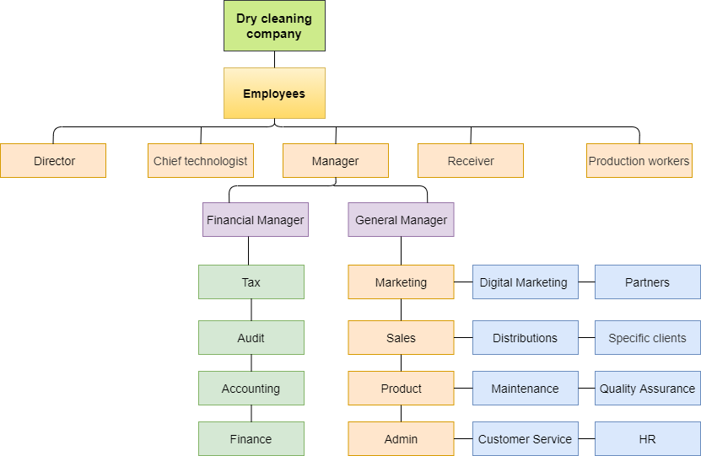

2.Build a business process model for your version using the EPC notation. Include as many elements as possible to the model. The model must contain logical operators.

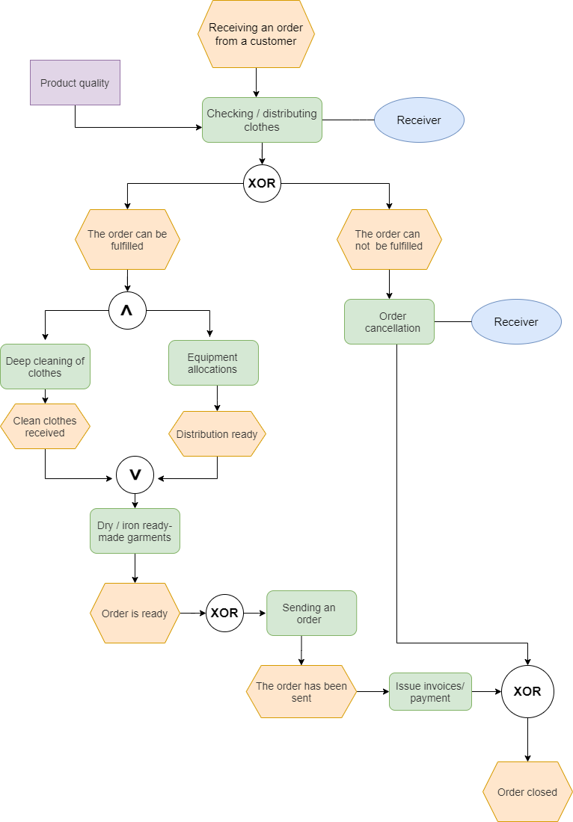

3.Create a tree of 2 functions.

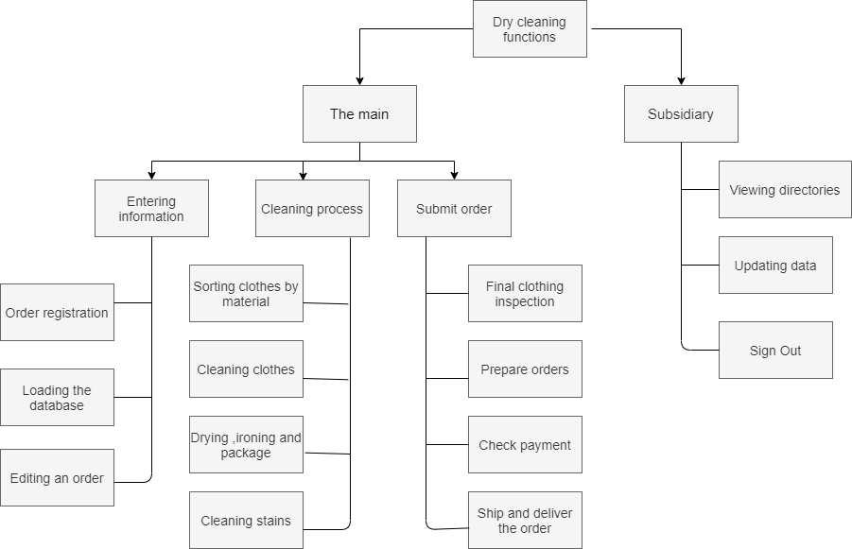

4.Create a VAD diagram from the process hierarchy diagram created in Laboratory 1.

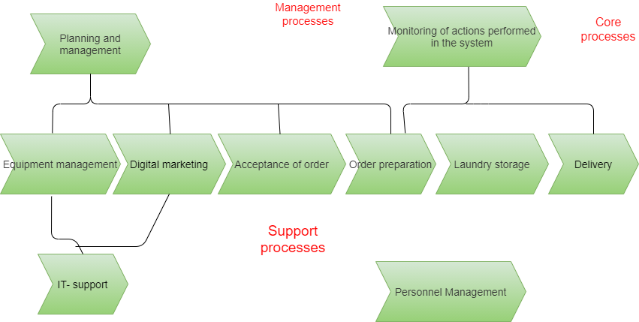

**EPC models of technical terms**

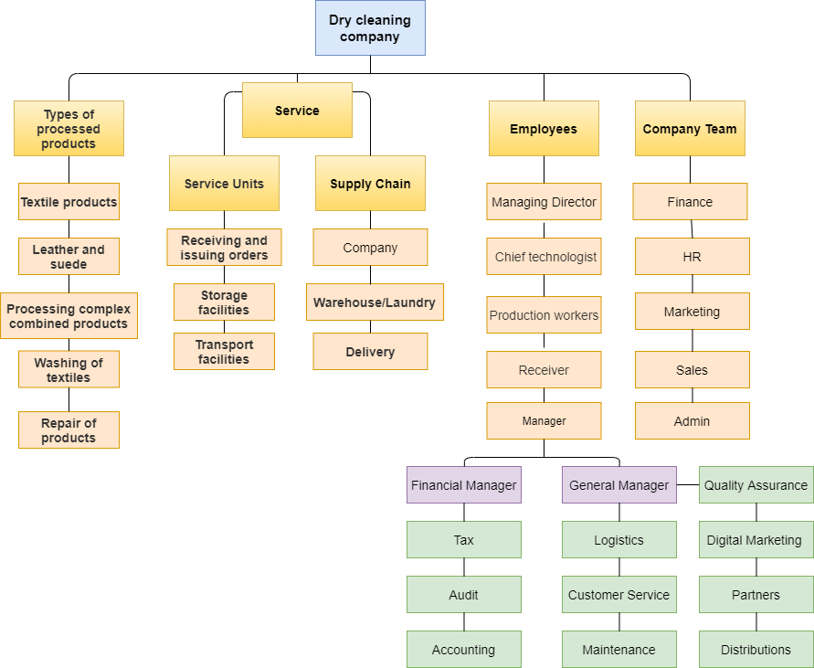

**Control Questions**

1. **Which structural elements are used to build an organizational chart?**

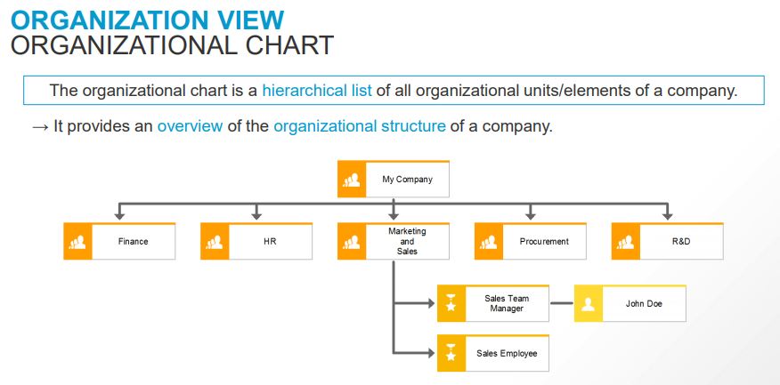

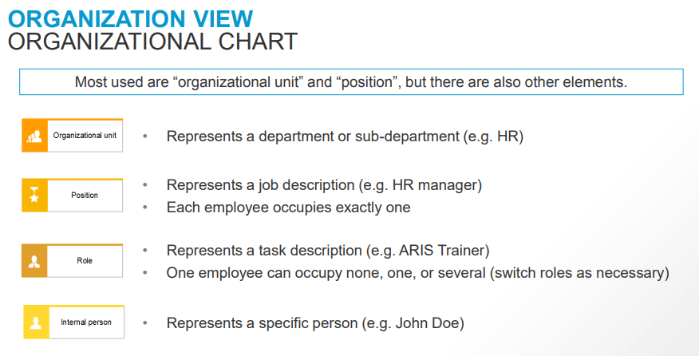

**2.What is the ISO standard?**

**SO 9001** is the international standard for a quality management system (“QMS”).  In order to be certified to the ISO 9001 standard, a company must follow the requirements set forth in this Standard.

ISO standards list four general types of outputs: services, software, hardware, and processed materials. However, ISO's very broad definition suggests that there are many more types of outputs.

So outputs could include also decisions, directions, instructions, plans, policies, proposals, solutions, expectations, regulations, requirements, recommendations, complaints, comments, measurements, and reports. Clearly, an output could be almost anything.

The ISO 9001 Standard is designed to manage and improve processes.

1. First, you identify your key processes.
2. Second, you define standards for those processes.
3. Third, you decide how the process will be measured and evaluated.
4. Fourth, you document your approach to achieving the desired quality, as determined by your measurements.
5. Fifth, you continuously improve.

**3.List the 5 views of aris house**

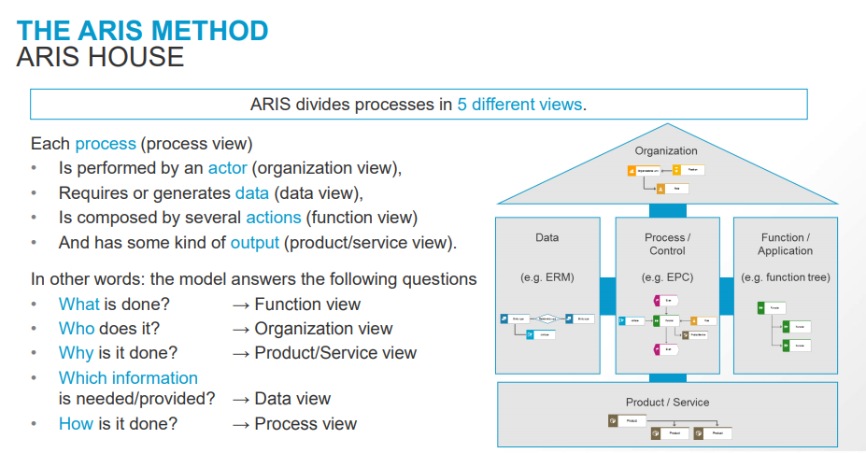

**4.EPC notation elements**

An **event-driven process chain** (**EPC**) is a type of flow chart for business process modeling. EPC can be used to configure enterprise resource planning execution, and for business process improvement

**1.Event.** Events are passive elements. They describe under what circumstances a function or a process works or which state a function or a process results in. Examples of events are "requirement captured", "material in stock", etc. In general, an EPC diagram must start with an event and end with an event.

**2.Function.** Functions are active elements in an EPC. Functions describe transformations from an initial state to a resulting state. Examples of functions are "capture requirement","check material in stock", etc.

**3. Organization unit**

Organization units determine which organization within the structure of an enterprise is responsible for a specific function. Examples are "sales department", "procurement department", etc. It is represented as an ellipse with a vertical line.

**4. Information, material, or resource object**

They can be input data serving as the basis for a function, or output data produced by a function. Examples are "material", "order", etc.

**5. Logical connector**

With the help of logical connectors it is possible to split the control flow from one flow to two or more flows and to synchronize the control flow from two or more flows to one flow.

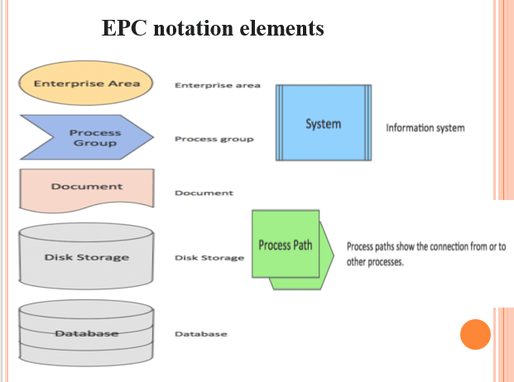

**5.Describe the stages of PDCA tool**

PDCA is a tool that can be used to manage processes and systems. ISO uses PDCA. PDCA stands for:

P - Plan: set the objectives of the system and processes to deliver results (“What to do” and “how to do it”)

D - Do: implement and control what was planned

C - Check: monitor and measure processes and results against policies, objectives and requirements and report results

A - Act: take actions to improve the performance of processes

PDCA operates as a cycle of continual improvement, with risk‐based thinking at each stage.